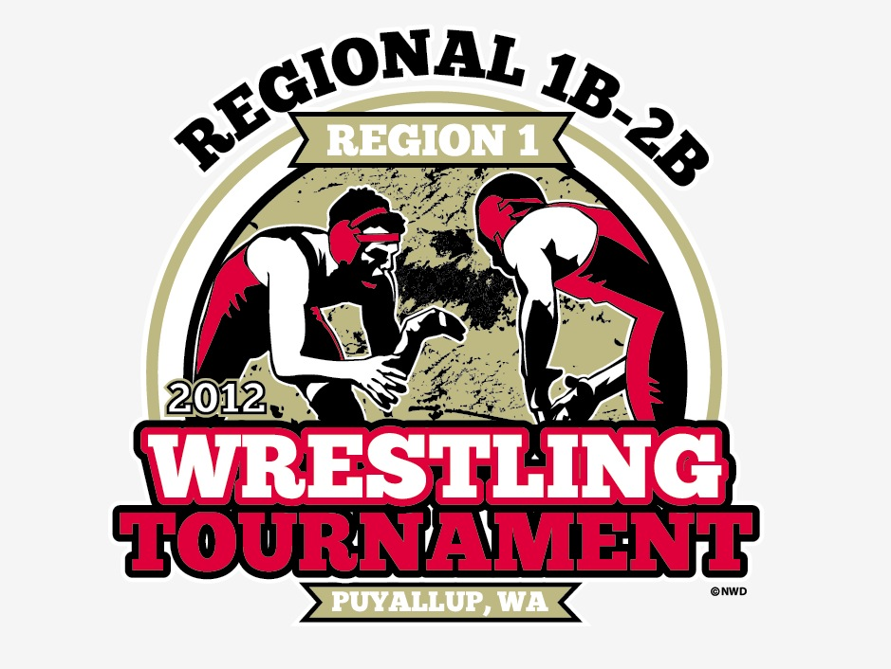**2012 Region 1 Boys 1B/2B Wrestling**

**Tournament Syllabus**

1. Date and Site
   1. Date- 2/11/2012
   2. Site- Chief Leschi High School
   3. Address- 5625 52nd Street East, Puyallup, WA 98371
   4. Contact Person- Audrey Adams, Athletic Director
   5. Phone- Work 253-445-6000 ext 3016, Cell 253-310-2065
   6. Fax- 253-445-2354
2. Time
   1. Weigh In- 7:30am, boys locker room
   2. Coaches Meeting- 9:15,Health Room
   3. Tournament Start- 10:00am
3. Tournament Director
   1. Audrey Adams, [audrey@leschischools.org](mailto:audrey@leschischools.org)
   2. 253-445-6000 ext 3016
   3. 253-310-2065, cell
4. Tournament Games Committee
   1. Audrey Adams, Tournament Director
   2. Head Official- TBD
   3. Mark Smith, AD Tacoma Baptist
   4. Kevin Goodrich, Head Coach Ocosta
   5. Dave Dellinger, HS Coach Concrete
5. Coaches Meeting
   1. 9:15am Health Room (past the locker rooms on your right)
      1. Review tournament policies and procedures
      2. Head Official info
      3. Trainer info
      4. Vote for MS Coach of the Year, ASST HS Coach of the Year and HS Coach of the Year
      5. Questions
6. Weigh In 7:30am
   1. Weigh in will take place in the boys locker room
   2. Weigh in will be done by teams on a first arrival at Pass Gate basis
   3. Athletes must have PICTURE ID and their WEIGH IN CARD
   4. Weigh in cards will be in the Coaches Packet
   5. There will be a 2 pound weight allowance
   6. We will be using the NFHS Wrestling Rules
7. Admission Prices
   1. We will open the gym doors for spectators at 8:00am
   2. Ticket prices
      1. Adults, student without ASB- $8.00
      2. Students with high school or middle school ASB card, Children under 12 years of age- $6.00
      3. Senior Citizen age 62 and up- $6.00
      4. Children 5 and under- $Free
8. Passes for Free Admission
   1. The following passes will be accepted for free admission to the tournament
      1. Washington State Coaches Association (WSCA)
      2. Washington State Athletic Directors (WSSAAA)
      3. Washington Officials Association
      4. Washington Honorary Lifetime Pass
         1. Note- All district passes, individual passes, league passes and school passes are not accepted.
9. Team/School Pass List- Must be faxed to Audrey Adams no later than Wednesday Feb 8th , 3:30pm
   1. Participants
   2. Coaches
   3. Managers
   4. Statisticians
   5. Video
   6. Cheerleaders (must be in uniform and included on the list) Max 8
   7. Cheer Coach 2
   8. Bus Driver will be admitted with valid ID
   9. No additional names may be added to the pass list
10. Tournament T-Shirts and Sweatshirts will be on sale
    1. Prices to be determined by Northwest Design
11. Session Schedule
    1. Session1- 10:00am
    2. There will be a 30 minute break between the conclusion of each session
    3. Session2- Consolation, Semi-Finals
    4. Session 3- Consolation
    5. Session 4-Third and Fourth/First and Second
12. Mat Classic Pre- Sale
    1. Mat Classic Pres-Sale tickets will be sold in foyer of the gym starting at 11:00am
       1. Ticket prices-
          1. Adults/Student without ASB- $23.00
          2. Students with high school or middle school ASB Card Children Under $12- $17.00
          3. Senior Citizens age 62 and up- $17.00
          4. Children 5 and Under- $Free
13. Awards
    1. Team Trophies- 1st place, 2nd place, 3rd place
    2. Individual Medals- 1st place, 2nd place, 3rd place
    3. Qualifiers to state- Top 3 places
    4. Pictures- State qualifiers pictures will be taken immediately after the awards. Must be in team uniform, no bandanas, hats etc for picture.
       1. They will be taken in the locker room hallway
14. Disputes-
    1. All disputes will be presented to the Tournament Manager who will forward them to the Games Committee for review and resolution
       1. Audrey Adams, Tournament Director
       2. Head Official- TBD
       3. Mark Smith, AD Tacoma Baptist
       4. Kevin Goodrich, Head Coach Ocosta
       5. Dave Dellinger, Head Coach Conrete
    2. WIAA ejection rule will be in effect. Wrestler will be barred from further competition (remainder of the Regional and All of the State Tournament) if:
       1. Ejected for first instance of flagrant misconduct (Federation rule) or,
       2. Ejection for the second instance of unsportsmanlike conduct (Federation rule) or an “abusive” nature (WIAA Standard)
       3. Ejection of a coach results in removal from the Regional Tournament and the first scheduled match the following year.
15. Facilities-
    1. Our facilities are limited and seating space maybe tight. We ask that all spectators limit themselves to their seats only.
    2. Locker rooms
       1. We will have 2 locker rooms with showers available
          1. Please plan to be responsible for securing your valuables. Also plan to keep locker rooms clean and garbage cans will be available in the locker rooms.
          2. Do not leave anything in the locker room
          3. Towels- **Bring Your Own**
          4. **Absolutely no Parents or Unpaid Coaches in the Locker Room Hallway**
          5. Floor restriction- No one will be permitted to stand along the mats, including coaches, wrestlers and spectators. There should be no one inside the roped area.
          6. The “Mat Room” will be open for wrestlers to go and relax and get away from the floor area.
          7. Warm up mats will also be at each end of the hallway
16. Breakfast
    1. Breakfast will be available from 8:00 to 9:30 in the Cafeteria
    2. Cost $4.00
17. School Banners only
    1. No other Types of signs are allowed
18. No school bands or any type of noise makers will be allowed
19. Team Scoring
    1. All tournament scoring will follow National Federation Rule Book Guidelines (Rule 9, Section 2)
       1. 1st place- 16 points
       2. 2nd place- 12 points
       3. 3rd place-9 points
       4. 4th place 7 points
       5. 5th place- 5 points
       6. 6th place- 3 points
20. Tournament Scoring
    1. Individual placement points shall be awarded as soon as earned. Placement points already earned will be deducted in case of forfeit (other than injury) or disqualification from the tournament.
    2. Points for team scoring shall be awarded as follows:
       1. (2) team advancement points shall be scored for each match won in the championship bracket, except, for the final first place match. If a wrestler receives a bye in the first round, he shall be awarded 2 advancement points for that round if he wins his next match. No points are awarded for the bye if he loses the next match.
       2. (1) team advancement point shall be scored for each match won in the consolation round, except for the final 3rd and 5th place matches. A wrestler who has a bye in the consolation round shall receive an advancement point, provided he wins in the next round match.
       3. Points for Default, Disqualification, Fall or Forfeit-
          1. 2 additional points will be scored for each match won by default
          2. 1.5 points will be awarded for each match won by a technical fall
          3. 1 point will be awarded for each match won by a major decision
21. Withdrawal of Qualifiers
    1. Any school that intends to withdraw a qualified participant should contact the tournament manager as soon as possible. This will allow time to contact the alternates.
22. Coach’s Hospitality Room
    1. We will have a hospitality room for paid coaching staff (2 per school), tournament volunteers and officials
    2. Entry by wrist band only- These are not to be shared
    3. Hospitality room will be open 10:00am until 6:00pm
23. Coaches packets
    1. Packets will be distributed when you arrive
    2. Available at a table in the foyers
    3. Weigh in cards are in the packet
    4. Wrist band for the hospitality room, two per school- NO SHARING
24. Directions to Chief Leschi
    1. From the South- Take I-5 north to exit 127- SR 512 and head east to the Canyon Road exit. Turn left on Canyon and head toward Pioneer. Turn left on Pioneer and take the first right on 52nd Street East. Cross the railroad tracks and the school entrance is on the left. Take a left at the Story Pole and the gym is at the back of the circle.
    2. From the North- Take I-5 south to exit 135- Bay Street. Go underneath the overpass and head straight, going past the casino. Stay in the right hand lane and veer onto Pioneer Way (do not go up the slight incline road near the cemetery) Stay on Pioneer Way for about 4 miles and take a left on 52nd Street East. Cross the railroad track and the school entrance is on the left. Take a left at the story pole and the gym is at the back of the circle.
25. Crowd Control
    1. This is a responsibility that must be shared by the administration and coaches of all participating schools. All of us must work closely with the Tournament Management to control the conduct of our student and adult fans.
    2. Coaches please inform your fans, athletes etc. that they are not allowed down at the mat area.
26. Media
    1. Only media and photographers with credentials cleared by the Tournament Manager will be allowed down by the mat area
    2. No video cameras of any kind (including cell phones) will be allowed on the floor. Any filming must take place from the stands.
    3. ONLY TWO COACHES IN EACH CORNER
    4. All photographers must take pictures from the stands
27. Concessions-
    1. Will be available in the Chief Leschi cafeteria from 10:00-6:00
28. Programs-
    1. Will be on sale cost $5.00

**REGION I PASS LIST**

**WRESTLING TOURNAMENT**

**E-MAIL or FAX THIS INFORMATION TO:**

[**audrey@leschischools.org**](mailto:audrey@leschischools.org) **253-445-2354**

**BY: WEDNESDAY, FEBRUARY 8th**

SCHOOL:

HEAD COACH:

ASSISTANT COACHES: CHEER COACH:

1. 1.

2. 2.

MANAGERS/STATS: CHEERLEADERS (MUST BE IN UNIFORM)

1. 1.

2. 2.

3. 3.

SUPERVISORS: 4.

1. 5.

2. 6.

3. 7.

4. 8.

CHEER COACH:

1.

2.

WRESTLERS/ALTERNATES:

1.

2.

3.

4.

5.

6.

7.

8.

9.

10.

11.

12.

13.

14.

15.